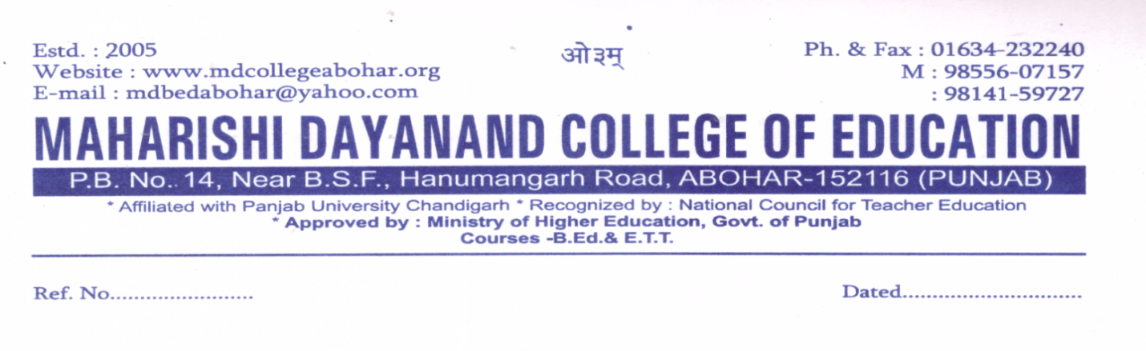
Preventation of sexual harassment committee
A meeting was held in the principal office dated 7/11/2020
Office bearers under session-2020-2021
- Mrs. Raj Rani (Chairperson)
- Dr.Geeta Rani (Principal)
- Mrs.Neetu Upveja (HEAD)
- Mrs.Rajdeep Kaur (Member)
Minutes of the meeting were as follows-
- Committee should tell the students about Sexual harassment prevention and complain cell.
- Committee should aware the students about Human Rights.
- Committee should collect the feedback from Parents, Students, Teachers and administrators.
- A notice was displayed on the notice board of the college.
Action taken:-
- No complaint
- If there is any complaint, action will take at our level and confidentiality will be maintained.
- Notice will be put on the notice board.
- Notice for students-sexual harassment committee is made, remarks in lighter way not allowed.
- Please take care.
