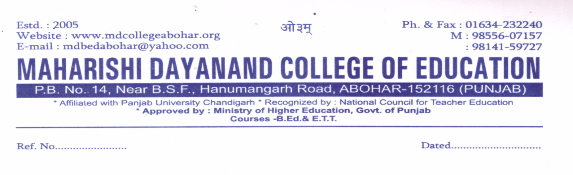
Feedback collected, analyzed and action taken report

A meeting was held in the principal office dated 27/10/2020
Office bearers under session-2020-2021
- Mrs.Neetu Upveja (HEAD)
- Mrs.Rajdeep Kaur (Member)
- Mr.Vishavdeep (Member/computer expert)
Minutes of the meeting were as follows-
- Committee should tell the students about Feedback Process.
- Committee should aware the students about internal assessment.
- Committee should collect the feedback from Parents, Students, Teachers and administrators.
- A notice was displayed on the notice board of the college.
Action taken:-
- Students may be aware of the process of internal level so that it is more fair and they will watch it so that it becomes unbiased.
- Teachers are persuaded to be always more punctual in the class.
